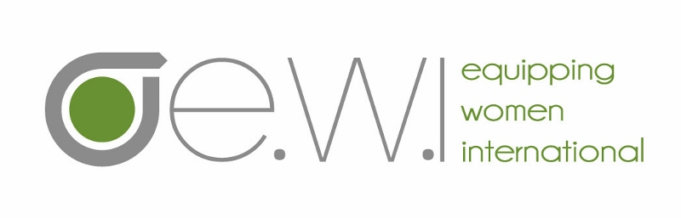
Application for EWI Training

(For first time registrants of EWI only)

Return to dlamp@barnabas.org

1. Name: Date:
Residence street address:
City: Country:
Zip/Postal Code:
USA Mobile: Country Mobile:
Country in which you currently reside:
What is your passport country?
Primary e-mail at which you wish to be contacted:
Do you live/work in a creative access country, a country in which security is a concern? ___Yes ___No
If so, is your email secure? ___Yes ___No
Please explain in detail the most secure way to contact you:
Can religious terminology be used in contacting you? ___Yes ___No
Skype: WhatsApp:
Facebook: Personal website:
Date of birth (month and day only):
2. List countries in which you’ve lived for more than six months:
3. What is your primary language (Mother Tongue)?
Are you fluent in a second language(s)? ___Yes ___No Specify which languages:
4. Because our courses are oriented to a post-high school literacy level, it’s important that participants are comfortable studying, writing and interacting in fluent English at this educational level.
HOW DO YOU ASSESS YOUR LEVEL OF ENGLISH?
- Reading: Fluent/High proficiency/ moderate proficiency/ low proficiency - (highlight level)
- Speaking: Fluent/High proficiency/ moderate proficiency/ low proficiency - (highlight level)
If English is not your mother tongue, please provide a name and contact information of someone who can confirm your level of English, not a family member.
Name: Contact info:
5. Name of your agency/employer:
Your position:
Full time Christian worker? ___Yes ___No
Number of years with your agency/employer:
Is your supervisor aware of and in favor of your attending this EWI course module? ___Yes ___No
If no, please explain:
Briefly descsexplain your ministry position or volunteer role at the agency with who you work (if applicable):
6. Name of church which you attend:
Church address:
Pastor’s name:
Church website address:
Church e-mail:
Is your pastor aware and supportive of your participation in this training? ___Yes ___No
If “No” please explain (in 300 words or less).
Church’s denominational affiliation:
Briefly describe/explain your ministry position or volunteer role at your church:
7. Personal status: Married/Single/Widowed/Separated/Divorced/Children in home - (highlight which applies)
Spouse’s last name (if different from yours):
Spouse’s first name:
If you are married, is your husband aware of and in favor of you taking this course module with Equipping Women International training? ___Yes ___No
If no, please explain:
8. Do you have any health restrictions/condition or current circumstance that might impact your ability to complete the 30 to 40 hours of preparation assignments and the 8-day intensive training week?
9. Describe your journey with Christ (in 1,000 words or less)
10. Briefly describe your current ministry and what you hope to gain from this training (in 500 words or less).
11. What previous schooling and training have you completed, both non-formal and formal:
What degrees or certificates have you obtained?
12 How did you learn of this Equipping Women International training opportunity?
If an individual referred you, what is their name and contact information?
13. This course module will require 30-40 hours of preparation homework, completed over a three month period. Do
you feel that you will have the time to complete this work before the first day of class?
___Yes ___No
A minimum of 80% of assignments must be completed to satisfactorily pass the module.

There are four course modules in the formation process. They are designed to be taken in order, #1 to #4, because they build upon each other. They are all listed here for your information.

Course Module Descriptions:

Facilitating Relational Learning* (FRL), module #1
In this module you will learn effective adult education principles and practices for all discipling situations. Adults learn best through interactive discussion, where members exercise their God-given gifts and life experiences to effectively learn from each other, as well as from the material studied. To practice this method, we will use the course Walking with Christ, a fundamental discipleship course that helps believers understand the supernatural resources available to live out their new life in Christ.
Participants will also be coached in how to plan and multiply servant-leader discipleship in their local settings. Also, a short overview of the whole curriculum and a description of how it’s being used to train and disciple women around the world will be given. This is a required module for all first-time participants in Equipping Women International.

Developing a Discerning Heart* (DDH), module #2:
This module aims to encourage godly women to help other women most effectively in peer relationships. To become an effective people helper, for our own sakes and for the sake of others, it is crucial that we first learn to look at our lives and problems biblically, and continue to grow in the sanctification process. Then, as a genuine outflow of our own relationship with God, we will learn to develop our skills and abilities to help others examine their own lives. This course is an exploration of basic counseling theory and skills—a beginning point. Although it’s not intended to produce professional counselors, it will give us a consistent and helpful framework for evaluating life’s tough questions and situations. The Facilitating Relational Learning module is a prerequisite course for DDH.

Discovery Bible Study* (DBS), module #3:
This module explores the foundational principles of personal Bible study skills using the inductive Bible study approach. Participants systematically work through a process of reading, observation, interpretation and application of Biblical passages in order to understand the original author’s intent and accurately apply the Word of God. Participants will prepare questions for and implement a small group Bible study, and a short sermon based on a passage that has been studied deeply, while keeping in mind the methods of an effective teacher. Participants will also have the opportunity to lead a thematic discussion one of the attributes of God. Learning how to rightly divide the Word of God in order to correctly teach, disciple, counsel and lead others is the focus of this course. Facilitating Relational Learning and Developing a Discerning Heart modules are prerequisites for DBS.

Women Serving Women* (WSW), module #4:
This module puts together the essential components for developing a leader, including an emphasis on knowing one’s own strengths and weakness, and on building an effective team. It builds a biblical framework for women-to-women ministry including identifying needs, resources, challenges, and opportunities in creating and sustaining meaningful service to other women. Spiritual gifts, temperaments, and effective spiritual mentoring are explored in the context of building a cohesive ministry to women. Required Prerequisites: Facilitator Relational Learning, Developing a Discerning Heart, and Discovery Bible Study.
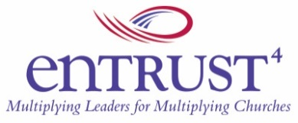

*This is an Entrust4 Women to Women Ministry Training course module, www.entrust4.org , with whom Barnabas’ Equipping Women International partners to offer these courses.

Return this form to Debbie Lamp at dlamp@barnabas.org.

DJL/8-10-12, rev. 5-13, 3-14, 3-15, 4-15, 1-16, 2-17

